Mark’s (DeveloperMode) Document on his journey to this project.

11/30/21

7:25PM

* If player’s model gets too dark, it’s because the geometry of the player inspector wasn’t enabled use in baked light 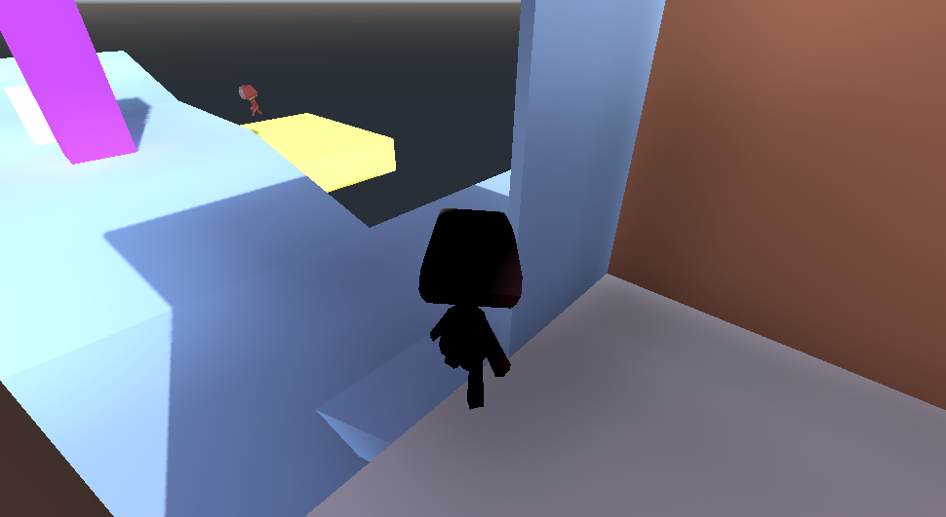be sure to enable it in the Inspector Area. Look at the screenshot below, the right part is the inspector. Find a label that said “Used In Baked Light” in the Geometry section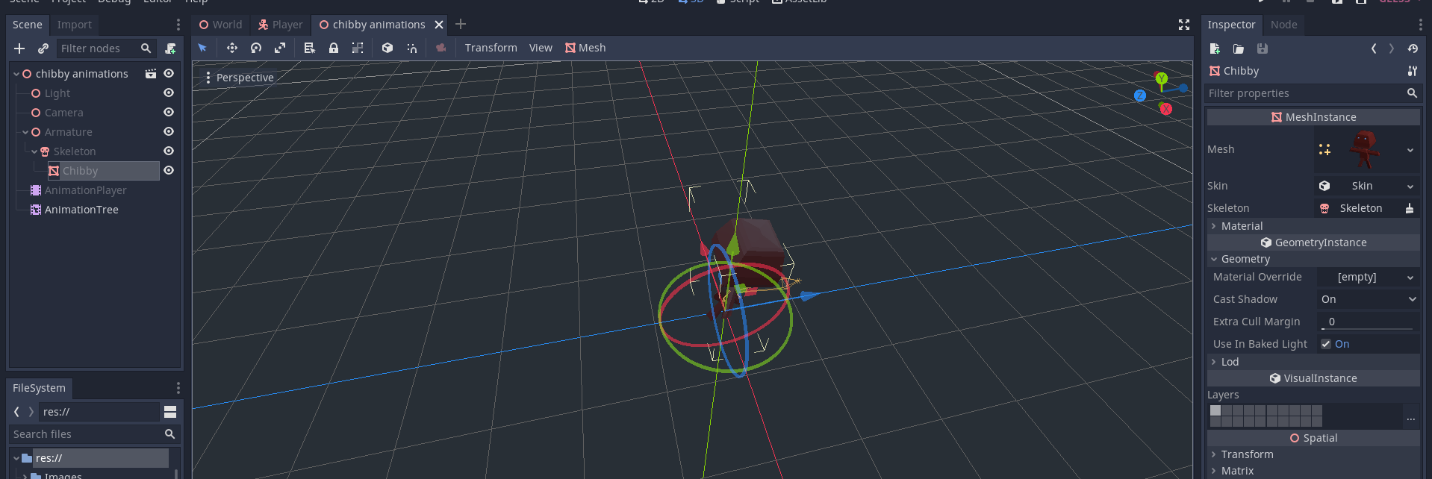I already enabled it so that’s good so that the GIProbe node will be able to render the player’s lighting as well. 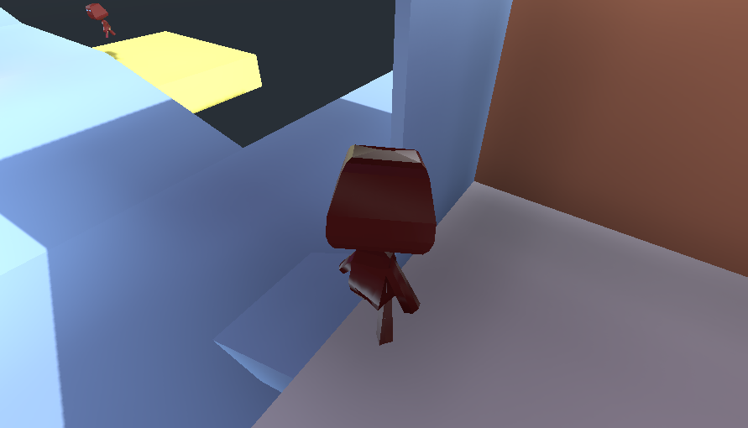

------------------------------------------------------------------------------------------------------------------------------------------

?:??PM

Write title here

Write description here